**SAVEETHA SCHOOL OF ENGINEERING**

**SAVEETHA INSTITUTE OF MEDICAL AND TECHNICAL SCIENCES CHENNAI-602105**

**AGRI MARKET**

**A CAPSTONE PROJECT REPORT**

*Submitted in the partial fulfillment for the completion of the course*

**CSA4317- INTERNET PROGRAMMING FOR MOBILE APP INTEGRATION**

**IN**

**COMPUTER SCIENCE AND ENGINEERING**

**Submitted by**

**K. Swapna kumari (192210118)**

**A. Sriveda (192210530)**

**Under the Supervision of**

**Ms. L. Reetha**

**NOV 2024**

## DECLARATION

We, K. Swapna kumari (192210118), A. Sriveda (192210530), students of Bachelor of Computer Science and Engineering, Saveetha Institute of Medical and Technical Sciences, Saveetha School of Engineering, Chennai, hereby declare that the work presented in this Capstone Project Work entitled **Agri Market** is the outcome of our own bonafide work and is correct to the best of our knowledge and this work has been undertaken taking care of Engineering Ethics.

K. Swapna kumari (192210118)

A. Sriveda (192210530)

Date: 23-11-2024

Place: SIMATS, Chennai-602105

## CERTIFICATE

This is to certify that the project entitled **“Agri Market”** submitted by K. Swapna kumari (192210118), A. Sriveda (192210530), has been carried out under my supervision. The project has been submitted as per the requirements in the current semester of BE. Computer science and Engineering.

Supervisor

Ms. L. Reetha

# Table of Contents

|  |  |  |
| --- | --- | --- |
| **S. No** | **TOPICS** | **Page No** |
| **1** | **Abstract** | **5** |
| **2** | **Introduction** | **6 – 7** |
| **3** | **Domain - Agriculture** | **8 – 11** |
| **4** | **Proposed Solution** | **12 – 15** |
| **5** | **Block Diagram/Flow Chart** | **16** |
| **6** | **Benefits of AgriConnect as an Integrated Solution** | **17** |
| **7** | **Technology Stack** | **18** |
| **8** | **Prototype/Webpage/Application** | **19 – 31** |
| **9** | **Future Scope** | **32** |
| **10** | **Conclusion** | **33** |
| **11** | **References** | **34** |

# ABSTRACT

Agri Market is a groundbreaking agricultural web platform designed to revolutionize the farming landscape. It is a user-friendly digital solution that bridges the gap between farmers, customers, laborers, and administrators in the agricultural ecosystem. This multifaceted platform serves as a one-stop destination for all agriculture-related needs.

Farmers are empowered to showcase and sell their farm produce, while also gaining access to a wide array of fertilizers, pesticides, and cultivation tools. Customers, in turn, benefit from the convenience of purchasing fresh, locally sourced farm produce directly from the platform. Job seekers within the agricultural sector can easily discover job opportunities, enhancing workforce mobility and efficiency.

Admins play a pivotal role in maintaining the platform's integrity by managing product listings, ensuring quality control, and handling additions and deletions.

In addition to its commerce functions, Agri Market offers a wealth of knowledge through articles, blogs, and news, making it a valuable resource for industry insights and information.

This innovative web platform not only modernizes agriculture but also promotes sustainable practices, streamlines distribution, and strengthens the agri-economy. Agri Market is poised to revolutionize agriculture by connecting, empowering, and enriching the lives of farmers, customers, laborers, and administrators.

# INTRODUCTION

**1.1 MOTIVATION**

During our field visit to Yerrajala, we interacted directly with local farmers, customers, and laborers. We observed that farmers faced numerous difficulties in selling their produce, obtaining necessary tools, and hiring laborers. Customers struggled to access fresh farm produce, while laborers found it challenging to locate job opportunities. Many farmers had to travel long distances to sell their crops, which was costly and time-consuming. Additionally, they lacked access to modern farming tools and fertilizers, limiting their productivity and income.

Witnessing these struggles firsthand motivated us to develop Agri Market. This platform aims to create a seamless connection between farmers, customers, laborers, and administrators, ultimately improving the livelihoods of local communities like Yerrajala and potentially benefiting other similar areas.

## 1.2 PROBLEM MOTIVATION

The agricultural sector lacks a centralized, efficient system to connect stakeholders. Farmers face challenges in selling produce, sourcing agricultural inputs, and hiring labor. Customers struggle to access fresh produce conveniently, while laborers encounter difficulties finding employment opportunities. Administrators need tools to manage these processes efficiently.

Agri Market addresses these issues by offering a unified web-based platform that empowers farmers to reach more customers, provides customers with easy access to fresh produce, connects laborers with job opportunities, and enables administrators to manage the marketplace effectively.

## 1.3 OBJECTIVES

* Provide a platform for farmers to list and sell their produce to a broader customer base.
* Facilitate the procurement of essential agricultural tools, fertilizers, and pesticides.
* Offer customers access to high-quality, farm-fresh produce.
* Connect laborers with job opportunities in the agricultural sector.
* Enable administrators to manage product listings, ensuring marketplace integrity.

**DOMAIN – AGRICULTURE**

Agriculture is a vital sector that sustains economies, provides livelihoods, and ensures food security for populations worldwide. In many regions, including India, agriculture remains the backbone of rural communities, contributing significantly to GDP and supporting millions of people. However, despite its importance, the agricultural sector faces numerous challenges, especially in rural and remote areas where access to markets, resources, and technological advancements is limited. The sector encompasses a wide range of activities, including crop cultivation, animal husbandry, horticulture, and agro-processing, each playing a critical role in the food supply chain.

In the traditional agricultural setup, farmers grow crops and livestock to meet both local demand and commercial needs. However, the agricultural landscape has evolved, driven by changes in population, climate, and technology. Today, there is a growing need to improve agricultural productivity and efficiency to feed a rapidly growing global population while minimizing environmental impact. At the same time, farmers require better access to markets, resources, and job opportunities to ensure sustainable livelihoods. Modern agriculture seeks to address these needs by integrating innovative practices, digital platforms, and sustainable techniques.

**Challenges in Agriculture**

Agriculture in rural areas like Yerrajala faces multiple challenges:

* **Limited Market Access**: Farmers often struggle to find direct markets for their produce, relying on intermediaries who take a large share of profits. This practice reduces farmers' earnings and diminishes the value of their hard work.
* **Difficulty Accessing Resources**: Farmers need access to quality seeds, fertilizers, pesticides, and tools, which are not always readily available in remote areas. These inputs are essential for crop growth and productivity, and without them, farmers face diminished yields and economic losses.
* **Seasonal Employment Opportunities**: Laborers who work in agriculture often face employment gaps due to the seasonal nature of farming. They may struggle to find consistent work within their locality, affecting their income stability.
* **Low Technological Adoption**: The adoption of digital platforms in rural agriculture is limited, largely due to a lack of access to technology, digital literacy, and financial resources. Farmers in rural areas may not have access to smartphones or the internet, restricting their ability to connect to larger markets or gain insights into improved farming techniques.

**The Role of Digital Platforms in Agriculture**

Digital platforms hold immense potential to transform the agricultural domain by addressing the above challenges. These platforms offer a centralized space where farmers, customers, laborers, and administrators can connect, exchange information, and transact directly. Digital agriculture platforms can:

* Enable farmers to list and sell their products directly to customers, thereby increasing transparency, reducing reliance on intermediaries, and enhancing their profit margins.
* Allow customers to source fresh and reliable agricultural products directly from farmers, ensuring quality and supporting local agriculture.
* Provide laborers with a space to find seasonal job opportunities with farmers in need of assistance, stabilizing employment and contributing to local economies.
* Empower administrators to manage and organize listings, ensuring a trustworthy and highquality platform that benefits all users.

Digital platforms also offer additional advantages by providing information on best practices, market prices, and weather forecasts, which can help farmers make informed decisions, improve crop yield, and respond to market demands effectively. These platforms bring the benefits of modern technology to even the most remote communities, making agriculture more resilient, profitable, and sustainable.

**Agri Market’s Role in the Agriculture Domain**

Agri Market is designed as a solution specifically tailored to the agricultural domain, addressing the distinct needs of farmers, customers, laborers, and administrators. By facilitating direct connections between these stakeholders, Agri Market bridges the gap between urban and rural areas, helping to create an interconnected agricultural ecosystem. Here’s how Agri Market aligns with and supports the agriculture domain:

* **Farmer Empowerment**: Agri Market empowers farmers by giving them a platform to sell their crops, access essential resources like fertilizers and tools, and gain direct exposure to customers. By bypassing intermediaries, farmers can increase their revenue, which contributes to improving their overall quality of life.
* **Enhanced Customer Access**: For consumers, Agri Market provides a reliable source of fresh, high-quality farm produce directly from local farmers. Customers benefit from knowing the origin of their food, which builds trust and supports sustainable, local agriculture.
* **Laborer Employment Opportunities**: Laborers in rural areas often struggle to find consistent employment opportunities. AgriMarket serves as a job portal where agricultural workers can find seasonal work, helping them secure a more stable income and support their families.
* **Administrative Management**: The administrative section of Agrimarket ensures that the marketplace is well-regulated and that only quality products and genuine users are listed. This oversight increases the platform's credibility, making it a trustworthy source for all users and enabling smooth operation.

**The Potential Impact of Agrimarket on Agriculture**

Agrimarket has the potential to make a lasting impact on the agricultural domain by:

* **Improving Economic Outcomes**: By eliminating intermediaries, Agrimarket can help farmers achieve better profit margins. Customers benefit from lower prices, while laborers find employment, contributing to economic growth in rural areas.
* **Encouraging Sustainable Practices**: Through access to resources and information, Agrimarket encourages farmers to adopt sustainable farming practices. The educational resources on the platform, including articles and blogs, provide insights into modern, ecofriendly agricultural techniques.
* **Reducing Post-Harvest Losses**: With direct market access, farmers can sell their produce promptly, reducing post-harvest losses that often occur when crops remain unsold. This feature is especially beneficial for perishable goods, helping reduce food wastage and improve food security.
* **Building a Resilient Agricultural Network**: Agrimarket’s integrated platform builds a strong community of farmers, consumers, and workers, each supporting one another. This network provides a foundation for resilience, allowing the agricultural domain to adapt to challenges like climate change, market fluctuations, and labor shortages.

In summary, Agrimarket’s platform represents a significant advancement within the agriculture domain. By addressing the primary challenges faced by rural farmers, customers, and laborers, it fosters an environment of growth, sustainability, and self-reliance. This project not only supports individual stakeholders but also contributes to the broader goal of a robust and sustainable agricultural ecosystem, vital for the well-being of communities and the stability of food systems. Through Agrimarket, we aim to make a meaningful contribution to the agricultural domain by harnessing the power of technology and connectivity.

# PROPOSED SOLUTION

Agrimarket is a comprehensive and integrated web platform designed to address the unique challenges and needs of stakeholders within the agricultural ecosystem, including farmers, customers, laborers, and administrators. By leveraging technology, Agrimarkett aims to bridge the gaps in the agricultural value chain, promote transparency, and improve accessibility, thereby fostering a more efficient, sustainable, and interconnected agricultural network.

Our solution offers a centralized platform where farmers can easily list and sell their produce, customers can directly purchase fresh agricultural products, laborers can find employment opportunities, and administrators can manage the platform’s integrity. Here’s how Agrimarket addresses each stakeholder's requirements in detail:

1. **Empowering Farmers** 
   * **Marketplace for Crops and Produce:** Agrimarket provides farmers with a user-friendly online marketplace where they can list their crops and farm produce for sale. This directto-customer approach eliminates intermediaries, ensuring that farmers receive fair prices for their goods and retain a larger share of the profits.
   * **Access to Agricultural Inputs:** Farmers often struggle to source essential inputs like fertilizers, pesticides, and farming tools, especially in rural areas. Through Agrimarket, farmers can browse and purchase these resources directly on the platform, simplifying the procurement process and ensuring they have access to quality products.
   * **Informed Decision-Making:**By providing product details, reviews, and recommendations, Agri market enables farmers to make well-informed choices about the products they purchase, improving the quality of their output and supporting sustainable farming practices. Access to such resources empowers farmers to increase productivity, reduce costs, and enhance the overall profitability of their operations.
2. **Improving Customer Experience** 
   * **Transparent and Reliable Purchasing:** By cutting out intermediaries, Agrimarket provides customers with a transparent buying experience. Customers can see where their food comes from, view product descriptions, and check reviews, which builds trust and enhances the quality assurance process within the agricultural supply chain.
   * **Support for Local Agriculture:** Agrimarket enables customers to support local farmers directly, fostering a connection between rural farmers and urban consumers. This support encourages farmers to continue producing and investing in their land, contributing to sustainable agricultural practices and food security.
3. **Facilitating Job Opportunities for Laborers** 
   * **Employment Platform for Agricultural Workers:** Agrimarket serves as a job portal for laborers seeking employment in the agricultural sector. Farmers can post job openings for tasks like harvesting, sowing, and land preparation, making it easier for laborers to find work that matches their skills and availability.
   * **Bridging Labor Supply and Demand:** Seasonal labor shortages are a common issue in agriculture, impacting productivity and timely harvesting. Agrimarket connects farmers with a pool of available laborers, ensuring they can find the workforce they need when it’s most critical. This solution addresses seasonal employment gaps and ensures a steady income for laborers, ultimately contributing to the rural economy.
   * **Job Matching and Notifications:** Agrimarket includes features like job matching and notifications to keep laborers informed about new job opportunities that match their preferences and skills. This functionality helps laborers stay connected to the market, minimizing the time and effort required to find work.

1. **Enabling Platform Administration and Integrity** 
   * **Administrator Role:** To ensure the platform runs smoothly and remains credible, Agrimarket includes an administrative layer where designated administrators oversee the platform's operations. Administrators manage product listings, user accounts, and reviews, ensuring that the platform remains secure, accurate, and up-to-date.
   * **Content Moderation:** Administrators have the authority to moderate content, approve or reject listings, and handle customer complaints. This role is crucial in maintaining the quality of the marketplace, verifying that only genuine products and listings are visible to users.
   * **Ensuring Data Accuracy and Compliance**: Administrators also ensure that all information on the platform is accurate and compliant with relevant agricultural regulations. This oversight not only enhances user trust but also aligns Agrimarket with best practices in digital agriculture and consumer protection.
2. **Knowledge Hub and Educational Resources** 
   * **Articles, Blogs, and News Updates:** Agrimarket goes beyond just being a marketplace by offering a rich library of articles, blogs, and news updates on agricultural topics. This knowledge hub helps farmers stay informed about the latest trends, innovations, and techniques in modern agriculture. It also provides valuable information on sustainable practices, pest control, crop management, and market trends.
   * **Improving Awareness and Skills:** By regularly publishing informative content, Agrimarket aims to enhance farmers' skills and knowledge. Access to updated information empowers farmers to adopt best practices, helping them optimize yields and improve the quality of their produce. This resource also benefits laborers, who can learn about skills that might enhance their job prospects and earning potential.
   * **Community Engagement and Support:** Agrimarket’s content section encourages farmers to engage with one another and share their experiences. This creates a sense of community, where users can ask questions, provide advice, and support one another. Such interactions foster a collaborative environment, enabling knowledge-sharing across the agricultural ecosystem.
3. **Leveraging Technology for an Integrated Solution** 
   * **Technology Stack:** Agrimarket uses a robust technology stack that includes HTML, CSS, and JavaScript for the frontend, PHP as the server-side scripting language, and MySQL as the backend database. The application is hosted on an XAMPP server, providing a scalable and accessible solution that ensures efficient and reliable performance.
   * **User-Friendly Interface:** The platform is designed with a focus on simplicity and accessibility, catering to users who may have limited experience with digital interfaces. The layout is intuitive, allowing users from all backgrounds to navigate and access the platform’s features without difficulty.
   * **Cross-Platform Accessibility:** Agrimarket is developed to be accessible across various devices, including desktop computers, tablets, and mobile phones. This cross-platform accessibility ensures that users can access the platform regardless of their device, making it easier for farmers and laborers in rural areas to stay connected.

**BLOCK DIAGRAM/FLOW CHART**

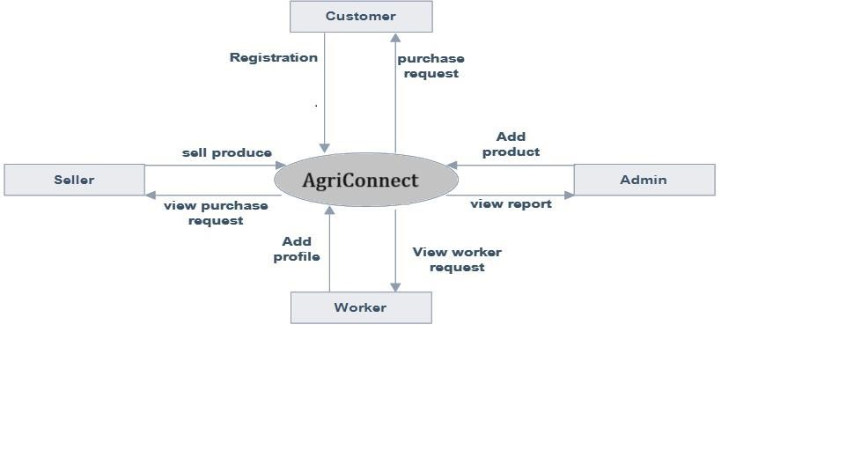

# BENEFITS OF AGRICONNECT AS AN INTEGRATED SOLUTION

1. **Economic Growth and Improved Livelihoods:** By providing a platform for farmers to sell directly to customers and for laborers to find job opportunities, Agrimarket supports the local economy and helps rural communities achieve greater economic stability.
2. **Enhanced Food Quality and Safety:** Direct-to-customer sales reduce the chances of contamination and spoilage, allowing customers to access fresh and high-quality products while supporting sustainable agricultural practices.
3. **Reduced Environmental Impact:** Agrimarket minimizes the need for transport and packaging associated with intermediaries, reducing the overall carbon footprint and promoting environmentally friendly practices in the agricultural sector.
4. **Empowerment through Information:** The platform’s educational resources empower farmers to adopt new techniques and improve productivity, supporting the long-term growth and sustainability of the agricultural sector.
5. **Community Building**: Agrimarket fosters a sense of community among its users, enabling farmers, customers, and laborers to engage, collaborate, and support one another. This sense of belonging is crucial for building trust and creating a resilient agricultural ecosystem.

**TECHNOLOGY STACK**

Agrimarkett is built using the following technology stack:

* **Frontend:** The platform’s user interface is created using HTML, CSS, and JavaScript to ensure a responsive and user-friendly experience. These tools allow us to design a visually appealing and accessible website that meets the needs of our target audience.
* **Server-Side Scripting:** PHP is used for server-side scripting, enabling dynamic content management and interaction with the backend database. PHP supports efficient handling of user requests, making it suitable for a platform with multiple stakeholders.
* **Backend Database:** MySQL is used as the backend database to store user information, product listings, transaction details, and other essential data. MySQL’s reliability and performance make it an ideal choice for managing the platform’s data.
* **Server:** XAMPP serves as the local development server, providing an integrated environment for developing and testing the platform.

|  |  |  |
| --- | --- | --- |
| **S. No** | **Component/Software Used** | **Specification** |
| 1 | HTML, CSS | Frontend Design |
| 2 | JavaScript | Frontend Interactivity |
| 3 | PHP | Server-side Scripting |
| 4 | MySQL | Backend Database |
| 5 | XAMPP Server | Development Environment |

➢ All these so softwares are self-hosted using free Open-Source Technologies.

# PROTOTYPE/WEBPAGE/APPLICATION

**Main Page:**

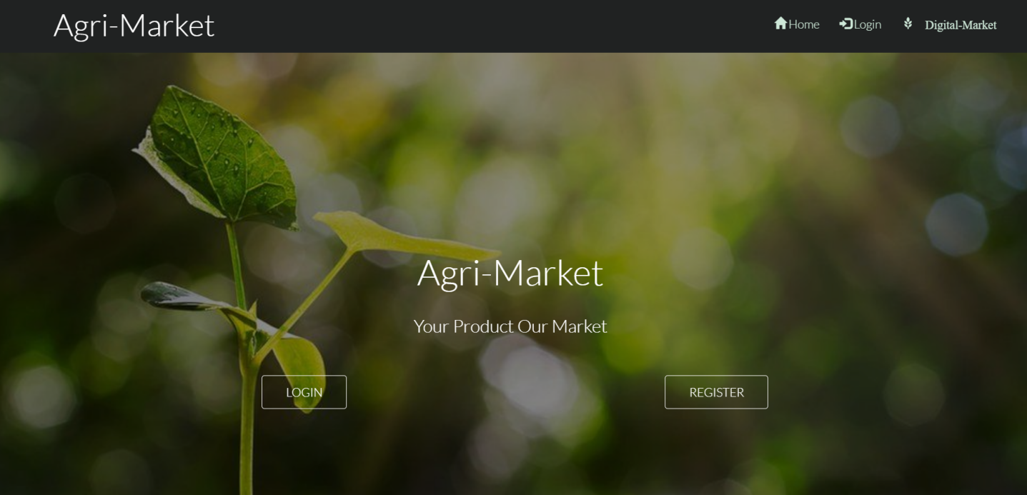

**Digital Market:**

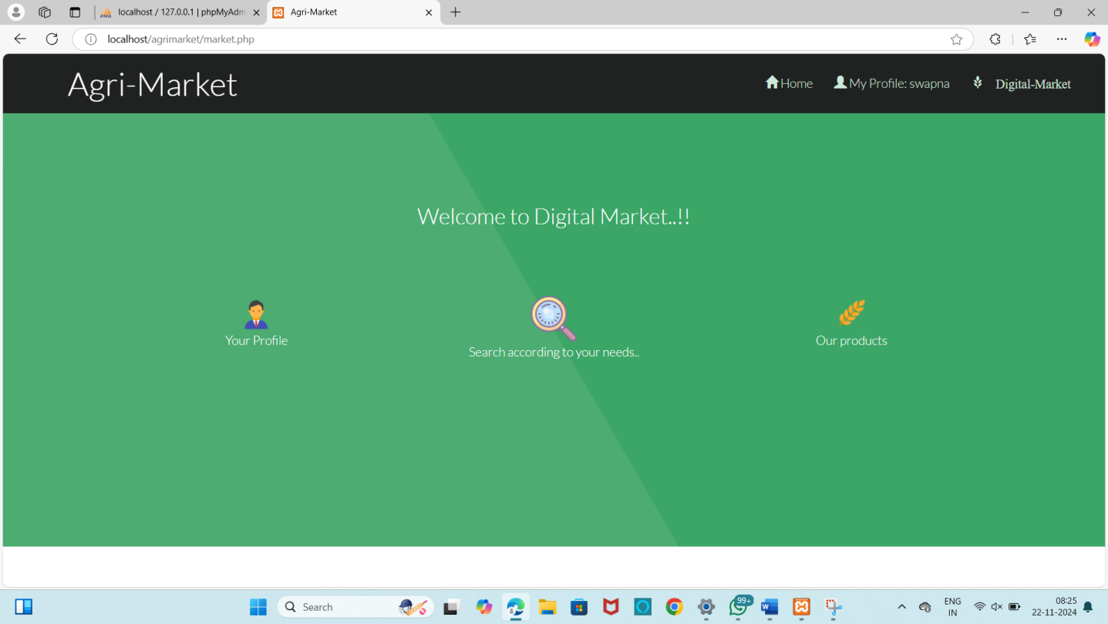

**Needs:**

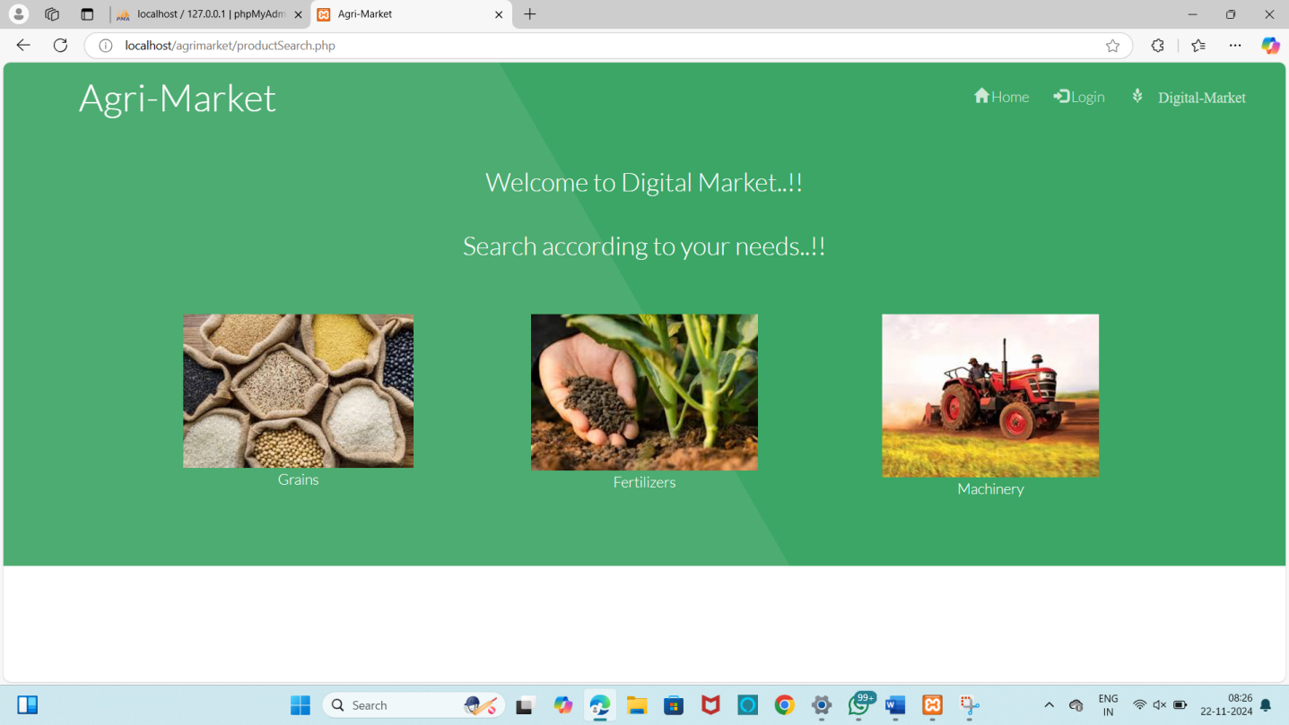

**Crop Table:**

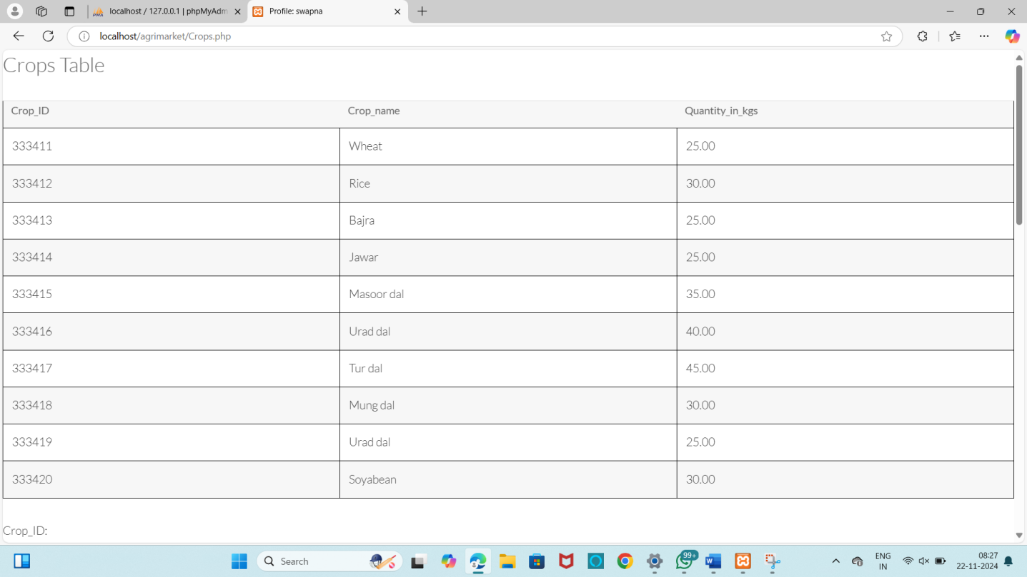

**Machinery table:**

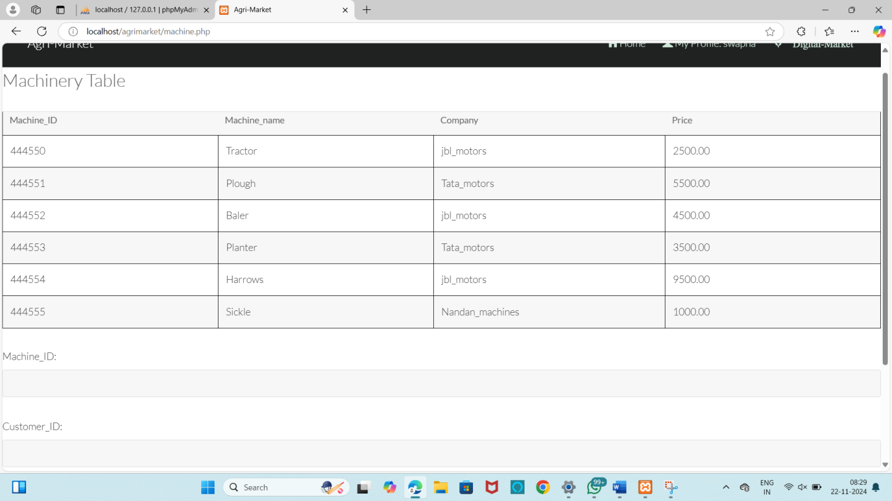

**My Account:**

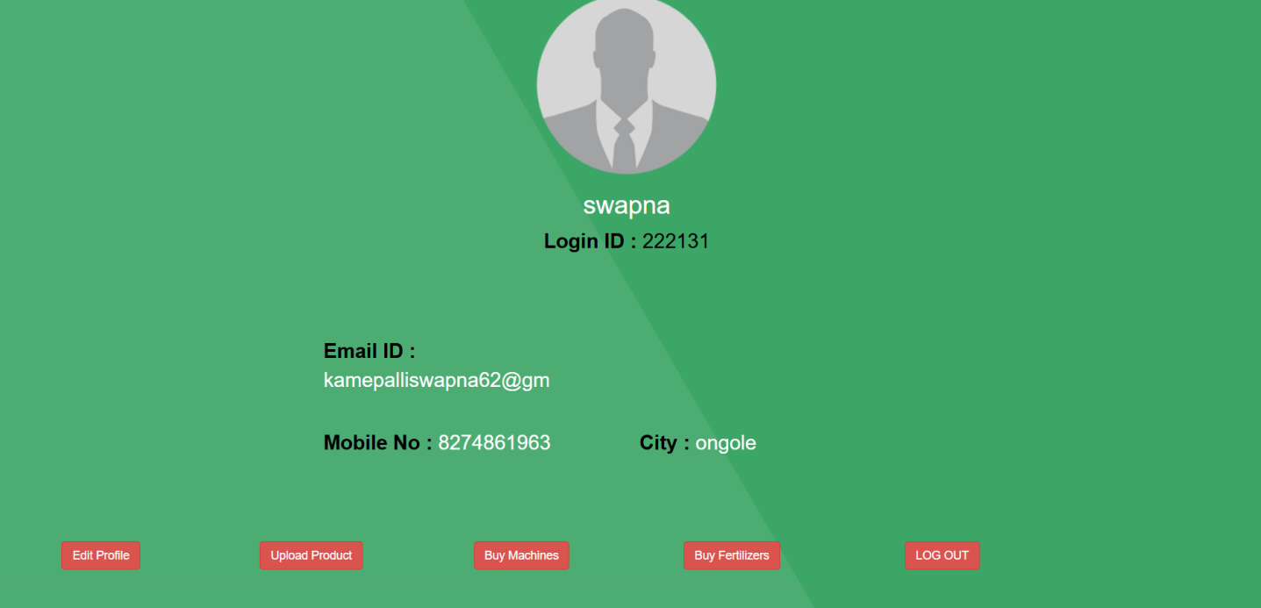

**As Customer:** 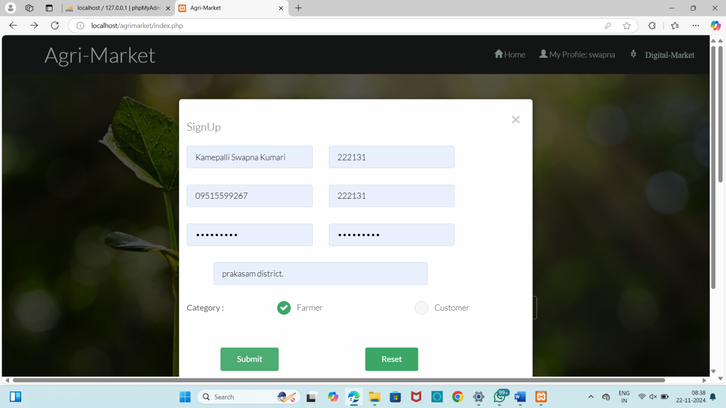

**As Farmer:**

**Register (Sign Up):**

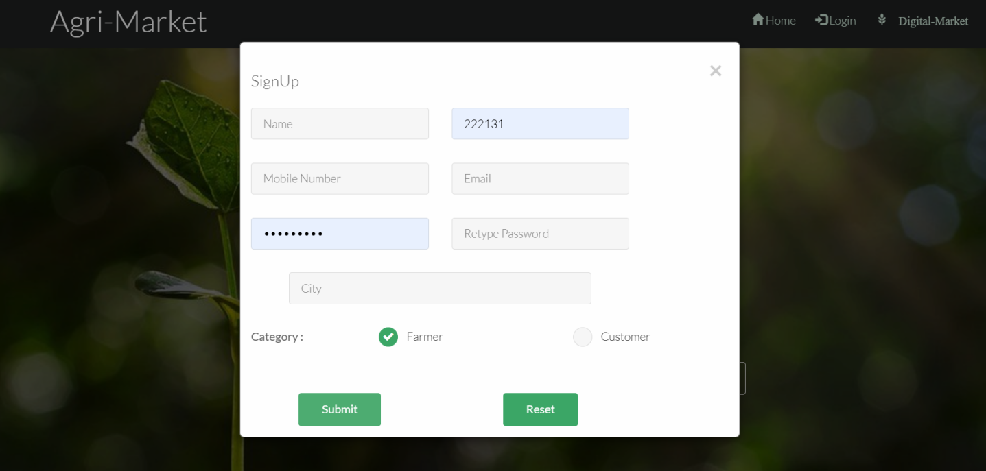

**Login (Sign In):**



**Product Information:**

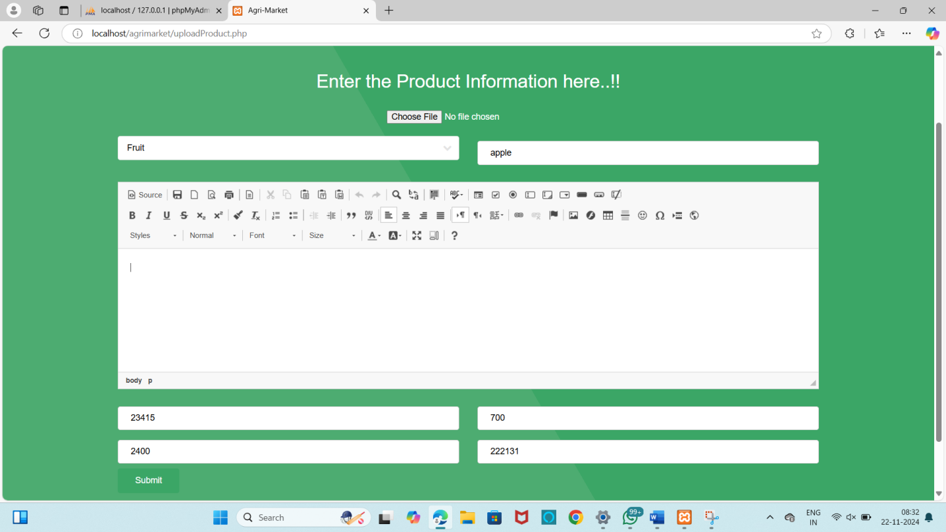

**Edit Profile:**

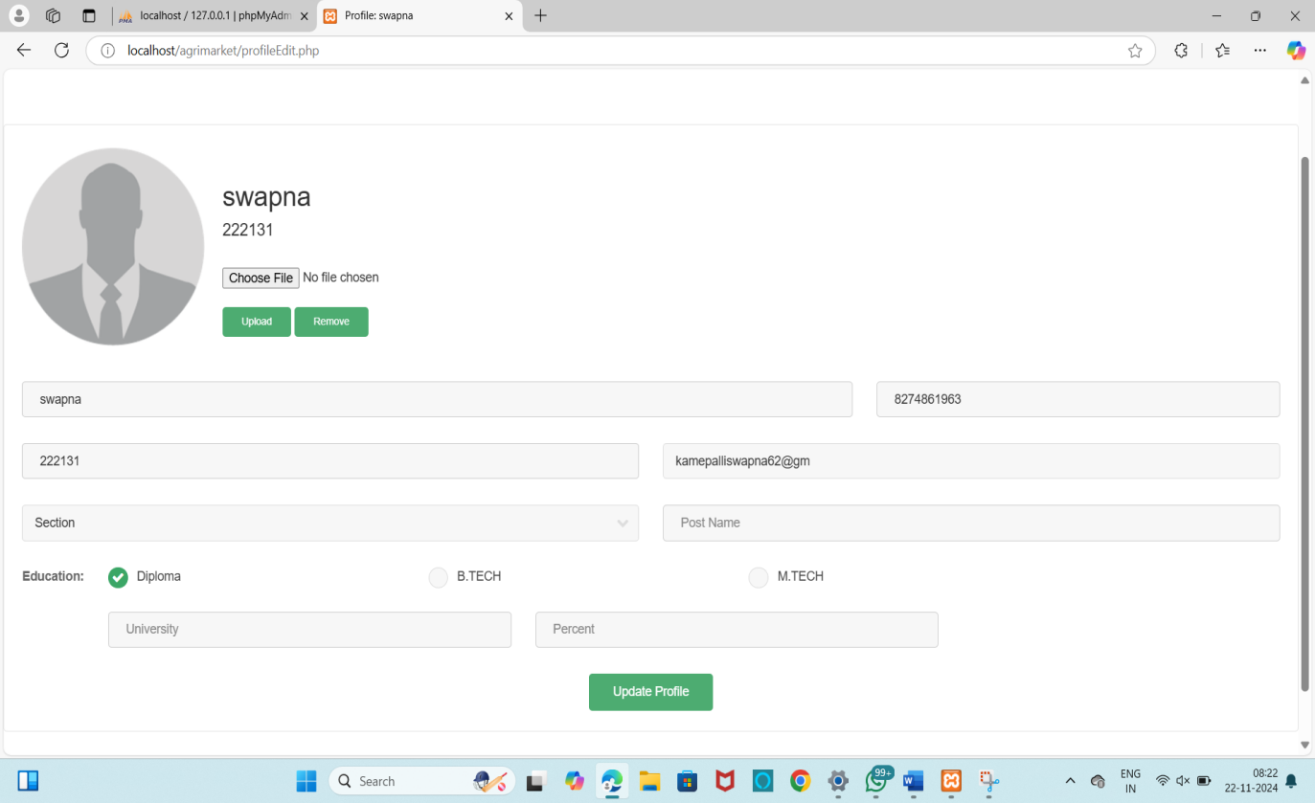

**Payment Gateway:**

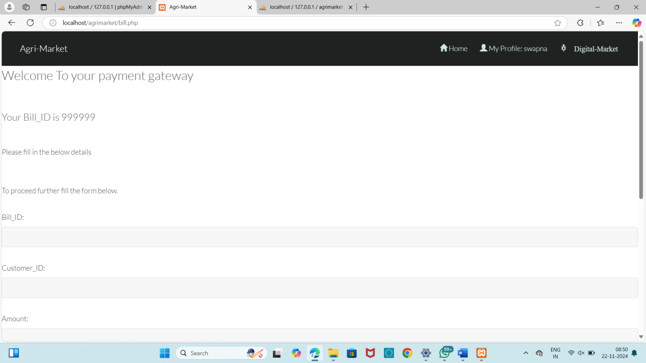

Transaction successful:

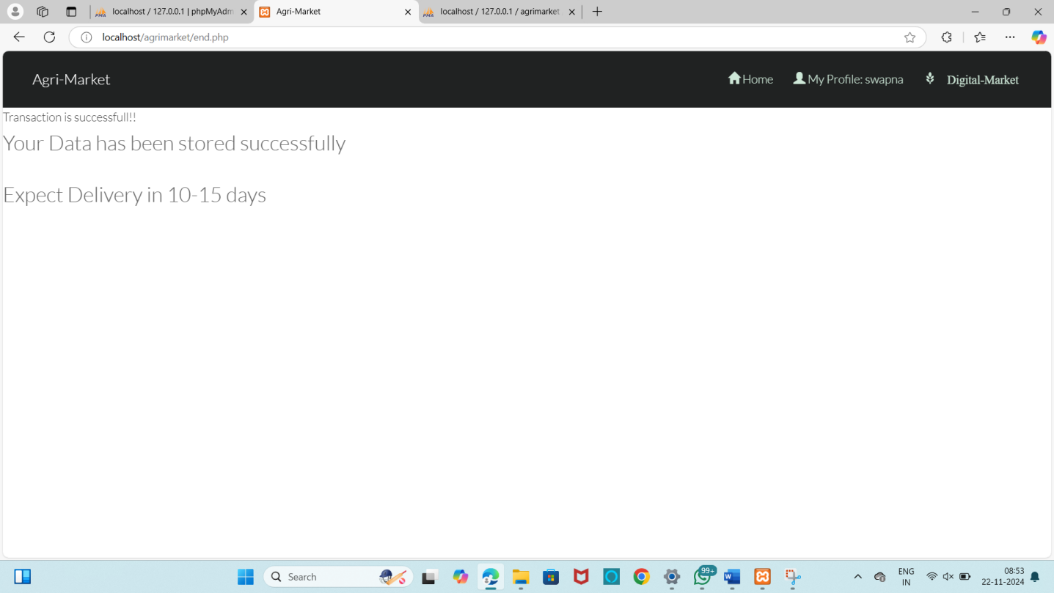

# CONCLUSION

Agri market has been developed as a transformative platform aimed at addressing the multifaceted challenges within the agricultural sector. By creating a centralized digital marketplace, Agri market connects farmers, customers, laborers, and administrators, fostering transparency, efficiency, and mutual support across all participants. The platform provides a direct market for farmers, offering them fair pricing and eliminating the dependency on intermediaries, while customers benefit from access to fresh, locally-sourced produce. Laborers find job opportunities that suit their skills, and administrators can maintain the platform’s integrity, ensuring a secure and reliable environment for all users.

Agri market’s integrated approach benefits not only individual stakeholders but also the broader agricultural ecosystem. By simplifying access to agricultural resources, labor, and fresh produce, the platform contributes to economic growth, promotes sustainable farming practices, and builds a sense of community. Furthermore, Agrimarket’s educational resources empower farmers to make informed decisions, improving productivity and quality in the long term.

This project demonstrates how digital innovation can revolutionize traditional sectors like agriculture, addressing real-world problems with practical solutions. Agri market is a step toward a future where technology and agriculture work hand-in-hand to improve livelihoods, support sustainable food production, and foster community resilience.

**FUTURE WORK**

While Agrimarket addresses key challenges in agriculture, there are some areas we plan to explore in the future to make the platform even more effective:

1. **Mobile App Development:** Creating a mobile version of Agrimarket to make it easier for farmers, customers, and laborers to access the platform on the go.
2. **AI-Based Recommendations:** Adding features like crop and tool recommendations based on data such as soil quality and weather, which could help farmers make better decisions.
3. **Payment Integration:** Implementing secure payment options like mobile wallets and bank transfers to make transactions simpler and cashless.
4. **Regional Language Support:** Expanding language options to make Agrimarket more accessible to farmers across different regions.
5. **Government and NGO Support:** Partnering with government agencies and NGOs to provide farmers with resources like training programs, subsidies, and financial assistance.

These enhancements would further strengthen Agrimarket’s impact, making it more accessible, practical, and helpful for the agricultural community. Our aim is to continue evolving the platform to support farmers, customers, and laborers in a seamless, sustainable way.

## 

## REFERENCES

1. Ul-Rehman, S., Selvaraj, M., & Syed, I. M. (2012). Indian agricultural marketing-A review. Asian Journal of Agriculture and Rural Development, 2(1), 69-75.
2. Karthick, S., Saminathan, R., & Gopinath, R. (2020). Agricultural marketing-An overview.

International Journal of Management (IJM), 11(11), 3007-3013.A

1. Dagar, G. (2015). Study of agriculture marketing. AIMA J. Manag. Res, 9(2/4), 1-9
2. Acharya, S. S. (2004). Agricultural marketing in India. Oxford and IBH publishing.
3. Balkrishna, B. B., & Deshmukh pandey, A. A. (2017). A study on role of social media in agriculture marketing and its scope. International Journal of Management, IT and Engineering, 7(4), 416-423.
4. Adekanye, T. O. (Ed.). (1988). Readings in agricultural marketing (pp. x+-215pp).
5. Meulenberg, M. T. (1997). Evolution of agricultural marketing institutions: a channel approach. In Agricultural marketing and consumer behavior in a changing world (pp. 95-108). Boston, MA:

Springer US.